1. **Write a C program to Graph traversal using Breadth First Search.**

**PROGRAM :**

#include <stdio.h>

#include <stdlib.h>

#define MAX 100

int visited[MAX];

int queue[MAX];

int front = -1, rear = -1;

void bfs(int graph[MAX][MAX], int vertices, int start);

int main() {

int vertices, edges, start, i, j;

int graph[MAX][MAX];

printf("Enter the number of vertices: ");

scanf("%d", &vertices);

printf("Enter the adjacency matrix:\n");

for (i = 0; i < vertices; i++) {

for (j = 0; j < vertices; j++) {

scanf("%d", &graph[i][j]);

}}

printf("Enter the starting vertex: ");

scanf("%d", &start);

for (i = 0; i < MAX; i++) {

visited[i] = 0; }

printf("BFS Traversal: ");

bfs(graph, vertices, start);

return 0;

}

void bfs(int graph[MAX][MAX], int vertices, int start) {

int i, vertex;

visited[start] = 1;

queue[++rear] = start;

while (front != rear) {

vertex = queue[++front];

printf("%d ", vertex);

for (i = 0; i < vertices; i++) {

if (graph[vertex][i] == 1 && !visited[i]) {

queue[++rear] = i;

visited[i] = 1;

}}}}

**INPUT:**

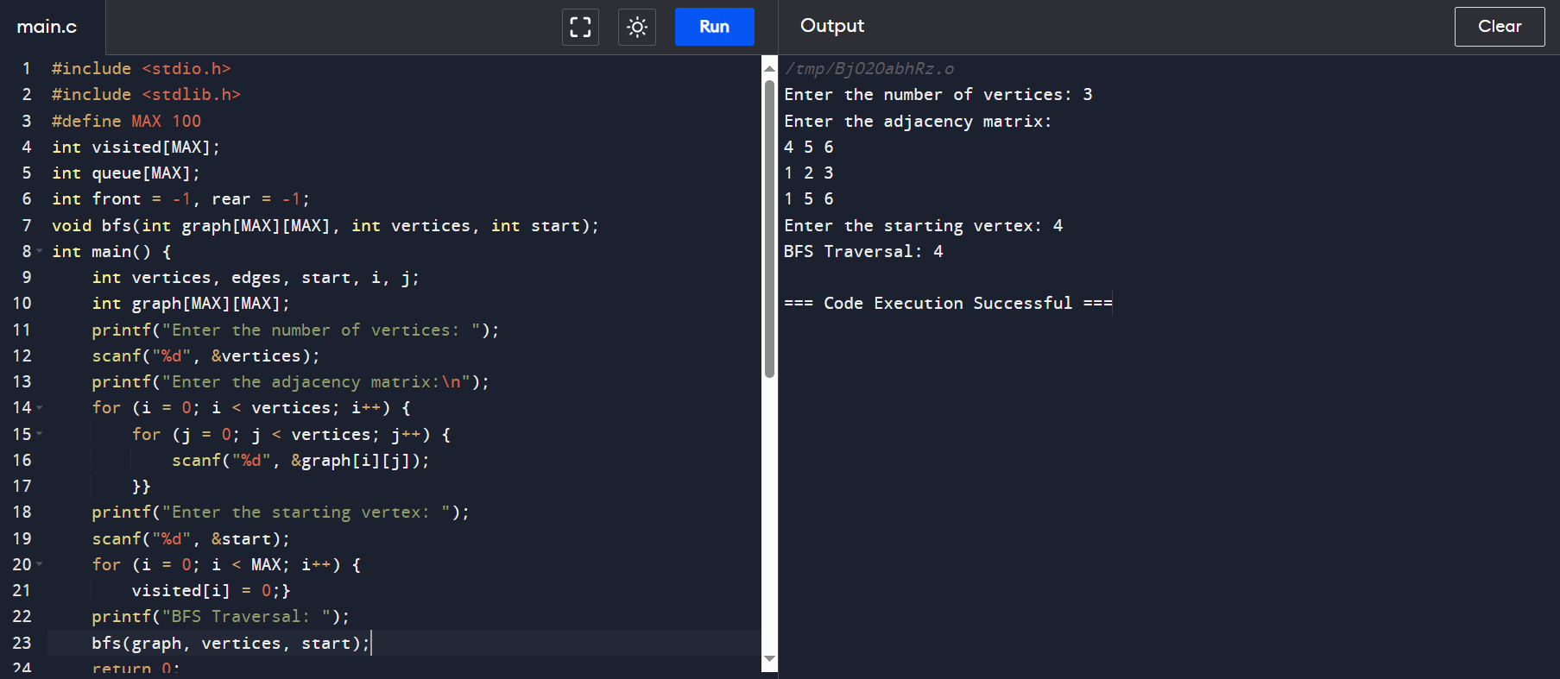

**OUTPUT:**

